By: S H

BCCE301 Cooperative Education Project

Semester 1, 2018.

Halfway Report

Cantabrian Rugby Football Club Website

Table of Contents

List of Abbreviations 4

Project Name 4

Background 4

Enterprise Involved 4

Business Opportunity 4

Project Goal 5

Objectives to Reach the Goal 5

Key Results or Expected Outcome 5

My Skills 6

Project Scope 7

Software Required 7

Hosting Server 7

Content Management System 7

Project Hierarchy - People Involved 7

Business/Club Supporting the Applicant: 7

Industry/Club Representative: 7

Enterprise Supervisor: 8

Academic Supervisor/Sponsor: 8

Project Manager (Student Nominee): 8

Project Parameters 8

Reporting Procedure 9

Threats / Risks 10

The project plan 11

Progress Made 11

Overview of Objectives 12

Documenation 12

Milestones Achieved 12

Risk Management Plan 13

Quality Assurance Plan 13

Website Design 13

Website Review 13

Problems Encountered 13

Personal Setbacks 13

Content Management Systems 13

Lack of Development Experince 13

Poor Time Management 13

Course Management 14

Academic 14

Industry 14

Personal Management 14

Review of Previous Courses 15

BCIS301V2 - Management of Information and Communication Technologies 15

BCIT352V1 - Multimedia Project 15

BCPR294V1 - Server-Side Web Programming 16

Database Management Systems – BCPR203 16

Software Engineering 2 – BCPR280 16

BCIS206 Professional Practice 16

Interactive Media App Development BCIT254 17

BCIS201V2 - Alternative Modelling 17

BCIS285V1 - SOFTWARE APPLICATIONS AND IS TESTING 17

BCIS290V1 - INTRODUCTION TO BUSINESS ANALYSIS 17

BCIS202V3 - Systems Design and Implementation 18

BCIT242V2 - Website Development 18

Project Plan 18

Time Management Plan 18

Risk Management Identification 18

Risk Types 19

Importance of Risk Management 19

Risk Management Plan 20

Outcomes of Risk Management 20

Quality Assurance 20

Quality Assurance Plan 20

Test Plan 20

Features Tested 21

Test Approach and Measurement 21

Usability Testing 21

Usability Metrics 21

Summary of Metrics 21

Overview of Metric 21

Critical Errors 21

Non-Critical Errors 21

Subjective Evaluations 22

Usability Test Plan 22

Functionality Testing 24

Outcomes of QA Plan 24

Content Audit 24

Website Architecture Plan 24

Methodoligies Essay 24

Content Management System 24

Website Design 24

Wireframe 24

Training Manual 24

Concept 24

Outcomes 24

Reflection 24

Appendices 25

References 26

# List of Abbreviations

|  |  |
| --- | --- |
| Cantabrian Rugby Football Club | CRBF |
| Content Management System | **CMS** |
| Industry/Academic Supervisor | **IS, AS** |

# Project Name

Cantabrian Rugby Football Club Website: <http://www.cantabrianrfc.co.nz/>

* Document, design, and publish a modern responsive website with a corresponding manual for the Content Management System.

# Background

Below illustrates the entire background of the project.

Cantabrian Rugby Football Club was formed in 1957 by a group of ex Canterbury representative Rugby players. Their mission is to foster rugby amongst the youth of Canterbury.

The CRFC’s current website will no longer be supported. Presently, the site is dated and requires a full redesign and will need to be moved to a new hosting platform – as the current host will be terminated.

The new site will need to be responsive and appropriate for the members and the target audience. A content management system will need to be implemented as the client would like to administer their own site updates. This will also require training materials for the CMS.

## Enterprise Involved

CRFC boasts a healthy 260 members. This number includes players, coaches, administrators, referees, plus kindred clubs throughout New Zealand. In the early days, the focus of members was getting out and coaching, arranging invitation games for charities. As the game evolved, the club adapted. Today, there is a big emphasis on rugby youth, particularly at second tier levels and their retention in the game, and primary school players.

Other features include, charity events such as the Annual Charity Golf Classic, an Annual Luncheon, involvement with a pre-test Charity Luncheon, and organizing get-to-gethers and re-unions.

Further information on the club can be located on their website:

<http://www.cantabrianrfc.co.nz/index.cfm/1,125,0,41,html/Brief-History>

# Business Opportunity

The cold fusion server’s that currently host the CRFC website will expire in April. Because of this, there is an opportunity to update the website and move it to a new host. The updated website will be fully responsive with a CMS, so the club can update, and edit their own site without the need for external input.

As many of the club members have never been a website editor or administrator, new roles would need to be designed and allocated to do this. A training manual will also be required to help those who have been allocated this role. These training manuals would include screenshots and/or videos. A one-off class could also be arranged if there are any further questions.

It was also expressed via a meeting, that the website colours are limited to and contrast well with the Cantabrian Logo/Monogram. i.e. colours: blue, yellow, black and white.

Summary of the above clients’ requirements illustrated below.

# Project Goal

To create a modern and responsive website with a content management system with an easy to understand user interface.

## Objectives to Reach the Goal

1. Modern look and feel of the website
2. Fully responsive i.e. mobile version
3. Eliminate the need for excessive sieving through the website to locate desired information
4. Display key imagery for the target audience i.e. Canterbury youth
5. New long-term hosting solution
6. Easy to understand training manuals
7. CMS for self-update and editing

# Key Results or Expected Outcome

1. That the client requires a new hosting platform for their domain
2. A website update; this includes layout and page redesign
3. Content management system. Which will need an easy to understand user interface, especially since the new site administrator may not have any website management background experience.
4. Training material that would teach new and old members how to edit and update the website.
   1. Further improve my technical writing skills.
5. Quality assurance process that will be documented to outline the overall quality for the website to adhere too during planning, construction and design.
   1. By completing the quality assurance documentation, I will have a full understanding of this process during website development as well as understand how to manage website quality during the website development life-cycle.
6. The website will be completely responsive, this includes mobile and iPad devices as well.
7. Risk management and analysis to be documented with contingency plans.
   1. As risk management in my opinion is a weekly process. I believe this will help me to manage risks during project development while designing and implementing the project with my risk analysis in mind to avoid issues further along in the project.
8. Further improve my ability for project management and time management during project development
9. Further improve my documentation skills
10. Improve my skills in project management and self-time management.
11. Will challenge and improve my problem-solving abilities for complex and unfamiliar situations that will help me after graduation
12. Further improve soft skills that will help in the industry environment

# My Skills

I have designed and implemented business websites for over three years now. Within that time, I have completed a variety of classes at Ara Institute of Canterbury to refine and gain new skills and knowledge for this line of work. This includes:

* BCIT352V1 - Multimedia Project
* BCPR294 Server-Side Web Programming PHP
* BCIS285V1 - Software Applications and IS Testing
* BCIT242V2 - Website Development.
* BCIT388V1 - Mobile Technology
* BCIT254V1 - Interactive Media Application Development
* BCIS301V2 - Management of Information and Communication Technologies
* BCPR280V1 - Software Engineering 2 (JavaScript)
* BCSE102V1 - Software Engineering 1 B (JavaScript)

I feel I am completely capable to achieve the project goal and meet my client’s requirements based on my skill set. I also feel this project will help to improve and refine these skills.

# Project Scope

After a meeting with Grant, five key requirements *(illustrated above)* have helped determine the project scope.

* All current content on the site will be re-organised and arranged on to the new website
* The domain i.e. [www.cantabrianrfc.co.nz](http://www.cantabrianrfc.co.nz) will remain the same
* It will be responsive for all devices with an emphasis on mobile devices
* A long-term hosting will be used
* A user-friendly CMS
* Design with a similar colour scheme as the previous website

It was also discussed what would not be included in this redesign.

* An online store to purchase club merchandise

# Software Required

## Hosting Server

This will be long-term solution that will require ongoing costs. Most likely monthly. Planning and testing will be done before the final decision is made.

## Content Management System

A content management will be attached to the website to help update and edit the website in a user-friendly interface. This can be downloaded and added without costs. However, extensive testing will be conducted to ensure it meets client requirements.

# Project Hierarchy - People Involved

## Business/Club Supporting the Applicant:

**Name:** Cantabrian Rugby Football Club

**Postal Address:** Cantabrian Rugby Football Club

PO Box 13328

Armagh

Christchurch

**Email:** cantabrians@gmail.com

## Industry/Club Representative:

**Name:** Grant McPhail

**Appointment Held:** Club Secretary

**Email:** Grant.McPhail@ara.ac.nz

**Telephone:** (03) 384 2096

## Enterprise Supervisor:

**Name:** Dr Christopher Bartlett **(Industry Supervisor)**

**Appointment Held**: Industry Supervisor

**Postal Address:** City Campus

Madras Street

P O Box 540

Christchurch 8140

**Email:** Christopher.Bartlett@ara.ac.nz

**Telephone:** +64 3 940 7500

## Academic Supervisor/Sponsor:

**Name:** Dr David Weir **(Academic Supervisor)**

**Postal Address:** City Campus

Madras Street

P O Box 540

Christchurch 8140

**Email:** David.Weir@ara.ac.nz

**Telephone:** 64 3 940 8324

## Project Manager (Student Nominee):

**Name:**  S H

**Postal Address:** 8 **************

**Telephone:** 027*******

**Email**: ********@gmail.com

# Project Parameters

**Projected start date:**

* Project commencement February 22, 2018
  + - Contact CRFC and IS an AS.

**Phase One: (4weeks) *Planning***

* Schedule weekly meetings with IS/AS
* Set-up a meeting with Grant (Club representative)
* Document project requirements
* Begin research to implement project requirements
* Begin Project Proposal

**Allocated Hours:** 40hrs.

**Actual Hours:** 40hrs.

**Phase two: (2 weeks) *Documentation*** (Currently in this phase)

* Present systems to industry supervisor for clarification
* Risk management identification, documented and contingency plans established.
* Quality assurance processes identified and documented, discussing the overall quality of the website and content management system set-up
* Contact Grant to update on project

**Allocated Hours:** 90hrs.

**Actual Hours:** 50 hrs to date. (*Will increase)*

**Phase three: (3 weeks) *Design***

* Design website
* Establish CMS parameters i.e. roles
* Training Manuals

**Allocated Hours:** 90hrs.

**Actual Hours:** TBC

**Phase four: (3 weeks) *Implementation***

* Begin implementation of new website
* Testing
* Update Documentation

**Allocated Hours:** 68hrs.

**Actual Hours:** TBC

|  |  |
| --- | --- |
| **Total Hours to meet:** | 288 |
| **Total Hours to Date:** | 90. (Will increase as project progresses) |

Have left an extra 12 hours in case the project falls behind expected hours and scheduling.

# Reporting Procedure

**Industry/Club Representative:** Grant McPhail

Will be sent the signed off project proposal. Furthermore, I will send fortnightly updates on the projects progression via email.

If I have any questions regarding the project I will send it via email.

**Academic Supervisor:** David Weir

The academic supervisor will be provided with a completed project proposal. He will also receive weekly documented reports of the proves and tasks completed, this will be sent via email. These project reports will outline tasks completed, achievements and issues that may have occurred during the week. Additional tasks will be agreed upon in weekly meetings.

**Industry Supervisor:** Chris Bartlett

Specific tasks will be completed, documented and presented during weekly meetings to help with the completion of project requires. This includes research on the correct and most effective systems to implement the project with. Weekly documented reports about the project process and progression will also be sent via email.

All excess documents such as content audits and analysis reports on CMS will be added to my appendix in my final report.

# Threats / Risks

Summary of the threats to the success of the project and the way in which it can be managed.

**Software Incompatibility**

* The CMS and hosting server do not meet each other’s compatibility standards
* Plugin modules for the CMS do not run correctly on the server
  + Research compatibility between CMS and server
  + Test CMS and Server before project implementation to avoid running into issues later in the project life cycle. Use test environments.

**Project Design**

* Agreement on project design changes
  + Make sure to finalise the favoured project design from my industry supervisor and client

**Project Scope**

* Does not meet SE301 expectations
  + Clearly express the specific requirements for the project and the scope. Make sure to get it marked off and okayed.

# The project plan

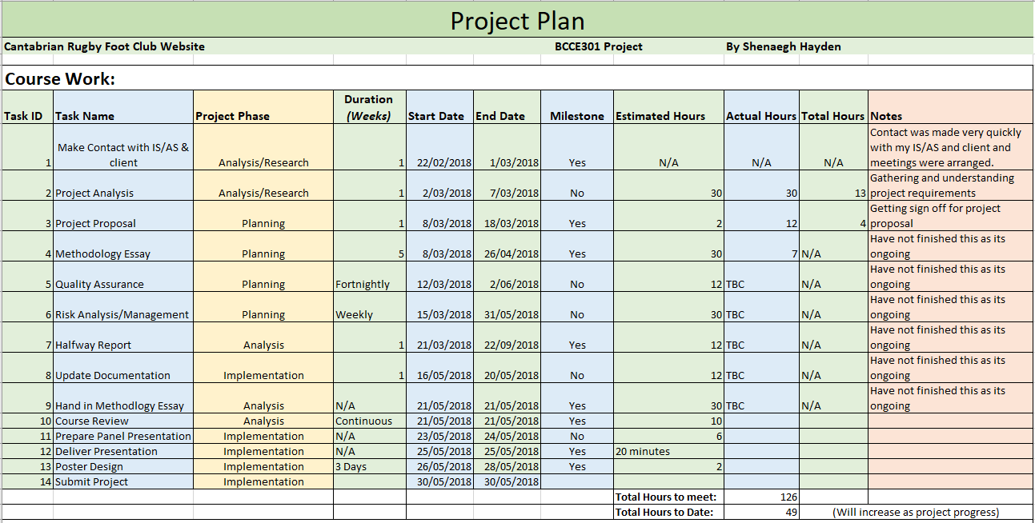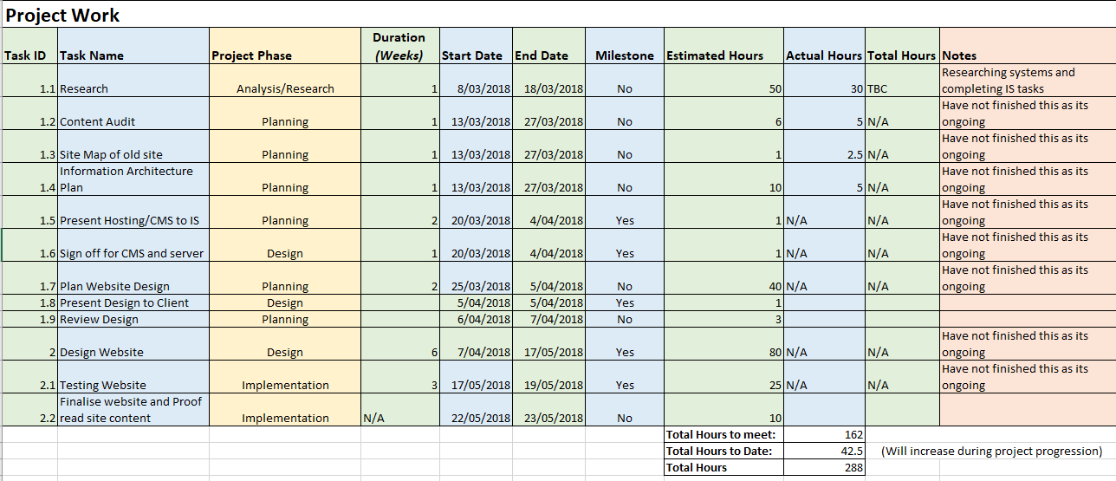

# Progress Made

At this point in time, the project is well developed only requires additional testing. I am waiting for other members of the Cantabrian Rugby Football Club to review the website and give me feedback for improvement. However, I have a working website that I showcase, which I’m very proud of. I believe I will continue to update the website until my client is happy with everything.

In terms of documentation, there is a lot. I have moved through each of my identified phases.

* Planning
* Design
* Development
* Launch/testing
* Review
* Maintenance

All my documentation is up to date and I’m currently working on final versions and revising all the content.

## Overview of Objectives

### Documenation

|  |  |  |
| --- | --- | --- |
| Name | Status | Comment |
| Project Proposal | Completed | Accepted by IS, AS and client |
| Risk management, contingency planning | Weekly revising | Final week will be finished. Document will then be complete and revised weeks will be added to appendices. |
| Quality Assurance Measures | Fortnightly revising | Final week will be finished. Document will then be complete and revised weeks will be added to appendices. |
| Project Plan | Revised | Will be in final report |
| Time management plan | Revised | Will be in final report |
| Mid Project Report – project progress | Behind schedule but finished | Adjustments to the project made and project progress documented |
| CMS Documentation | Underway - revised | Will be in final report |
| Wireframes, design process | Finished | Will be in final report |
| Content Audit | Completed – explained | Will be in final report |
| Website Architecture Plan | Completed – explained | Will be in final report |
| Course Evaluation | Completed – explained | Will be in final report |
| Methodology Essay | Completed – explained | Will be in final report |
| Training Manual | Near completion | Will be in final report |
| Test Plans – Usability/Functionality | Document completed – tests to be done | Will be in final report |
| Poster | Completed | Will be in final report |
| Final Presentation | To be completed | Will be in final report |
| Reflection | To be completed | Will be in final report |

## Milestones Achieved

Research of club websites and project management – methodologies

* Ensured that the project was obtainable in the time frame
* Gained understanding of the required functionality and documentation
* Gained understanding of some common issues and how to mitigate them

### Risk Management Plan

* Weekly risks identified and managed. Triggers, mitigation and contingency plans are all documented. Risk identification methods also documented.
* I also created detailed mitigation plans for top risks that were always present during the project development.
* Created a document that logs all on-going risks and their management plan

### Quality Assurance Plan

* Documentation on quality assurance plan for the project – completed fortnightly
* Metrics defined for determining the success of the final product.

### Website Design

* Gained experience in website development – for a client
* Designing a website with the colours red, black and white proved to be difficult
* Website has met client requirements – clients likes the design

### Website Review

* Client is happy with website progress
* Need to update photos – waiting on client’s photographer

## Problems Encountered

### Personal Setbacks

* I had a very terrible last few weeks of the project from a close relative passing. This setback my project by a few weeks and I had to mitigate this by completing huge hours in the final weeks

### Content Management Systems

* I was not familiar with any and I found I was struggling to understand them
* Research required
* Lack of documentation

### Lack of Development Experince

* Amount of research required while developing
* Unproductive at the beginning of the project

### Poor Time Management

* I did not manage my time very well at the beginning of the project

# Course Management

### Academic

At the beginning of the project I created most of my documentation templates which helped me further along in the project. I continuously added ideas in my documentation which helped to explain content and processes. When the time came to complete them, I had everything I needed and more.

As the project has progressed I felt the academic dominated most of my time through documentation and reporting.

### Industry

I have plenty of information and documentation created for my project. Also keeping in touch with my client and creating a website based off their requirements is challenging but achievable.

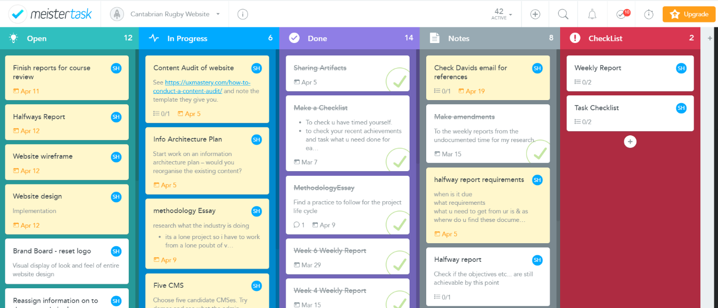Both academic and industry work was managed using Meister Tasker which is a free online software tool that used the Kanban Methodology to visually display the project process.

Figure 1 Kanban Project Management (Mesiter Task, 2018)

### Personal Management

I decided I would not work during the project. However, I ended up working part time which I then had to integrate into my life along with this project which is full time.

I also made a few compromises in other aspects of life. Below is an example of how many life has been during the process.

Weekly Reflection, weekly reports and progress meetings

• Summarizes daily trials, tribulations and emotions

• Summarizes weekly objectives and progress

• Talk about where I’m at. Major issues and successes.

# Review of Previous Courses

Below is a summary of what I learnt during the completion of these classes.

## BCIS301V2 - Management of Information and Communication Technologies

I heard a lot of negative feedback about this class and was interested. The first few classes were fine however, I found myself extremely lost during the entire duration of the course. Regarding what I learnt, I feel I extended on my knowledge of time management and project management. I found the teacher to be extremely tough on marking, but I understood that he was only pushing us to put as much effort into our work as possible. Class topics were different, but it helped me to understand the process of a functional analysis. I found COBIT evaluation on a functional analysis to be a little misleading as all job ads I have seen have not advertised that they use that framework. Overall, I found the class to be the hardest I have ever done and would not like to do it again. However, I do appreciate the skills I learnt from it. The most valuable being the ability to view an ICT project from all stakeholder perspectives.

A big improvement for the class would be to have someone readily available to help students who are currently attending it.

## BCIT352V1 - Multimedia Project

The main objective of the multimedia project was to ease me into the process of a semester long project. This class taught me three crucial skills that I have carried into BCCE301 course.

1. Time management
   1. There was a lot of documentation that needed to be completed during the media project. This meant I had to learn to document my time spent on tasks that would eventually be exported into a time sheet for evaluation at the end of the semester. To do this I utilised a free software to record my time spent on tasks.
2. Documentation
   1. Consistently reviewing my documentation to have a constant up to date version of it
3. Testing
   1. Never leave testing until the last minute perform usability and functional testing during the development process to identify and major faults early in the software.

I have no improvements for this class. It was extremely enjoyable.

## BCPR294V1 - Server-Side Web Programming

Website development and Design is a real passion of mine. This class helped me to learn PHP7. I did find it difficult because I had never hardcoded PHP. The main skill I learnt from this course was perseverance. To push through self-doubt and continue with your work even when its tough. I found although I hadn’t worked with own hardcoded PHP it was not difficult to understand. I will continue to teach myself PHP and strengthen this skill.

An improvement would be not to assume all students a familiar with PHP. Sending out emails with reading recommendations prior to the start of the semester can help students to ease into this class easier.

## Database Management Systems – BCPR203

This course taught me the importance of SQL to a web developer. Prior to this class I had never used SQL. I this to be an easy language to learn and I picked up on easily. Although I haven’t used SQL in my project, it has given me the basic knowledge of the language to utilise I the work force if need be. I will continue to strengthen this skill as I feel having the knowledge to use PHP, SQL and HTML together will make a strong web developer.

I enjoyed the structure and delivery of this class and have no improvement recommendations.

## Software Engineering 2 – BCPR280

JavaScript was always a difficult language for me to grasp. I found this class to be the hardest of all the classes I had done. This was due to the fact I never fully understood JavaScript until I got the last few weeks of the course when it all sunk in. I had to request a lot of help for this class and I found there were no one of one sessions available in learning services. However, the extra classes on a Friday were a big help. The exam for this class was a tough eight-hour PowerPoint. I believe that has changed now.

JavaScript is another language that is valuable for me in the line of work I would like to do. I do need to spend quite a bit of time refining my knowledge on this language as I can’t confidently boast about my skills in it.

## BCIS206 Professional Practice

I would have been happier completing this course in the Summer break rather than over a semester. I felt this class lacked stimulating content and structure. It was the easiest class I have done in my entire Bachelor. However, the industry visits were great (apart from Diane crashing the van).

This class helped improve my confidence for public speaking and presentations and taught me to answer questions openly in front of an audience/class. There was no hiding your thoughts in this class.

## Interactive Media App Development BCIT254

This was a favourite of mine. It was a great starter class to learn all aspects of multimedia development. Although I completed my main project on an outdated piece of software it helped me expand my knowledge on most Adobe products. The documentation from this class is a big reference point for me especially for testing and project proposals. I utilised my knowledge from this class to help me write my current documentation for my BCCE301 project. I enjoyed the creative freedom of this class and have no recommendations for improvement.

## BCIS201V2 - Alternative Modelling

This course focused on team work. A lot of the work was done in groups of four or more. I found this to be extremely frustrating in a student environment because each student has a different mindset while studying. Some did no work and others did most of the work. Although the course content was helpful, I mostly remember the terrible experience of trying to coordinate a team of five. I understand working in teams is a key concept in the industry, but in the student environment it’s a huge risk.

An improvement for this course would be to work I teams of two or three maximum, to prevent others slacking and hiding within the numbers of the group.

## BCIS285V1 - SOFTWARE APPLICATIONS AND IS TESTING

I had done testing in previous classes but none of them focused on test plans as much as this class. This type of testing helped me as developer identify defects early on in a project. Functionality testing and usability testing are crucial in web development. Test planning is perhaps the most important phase of testing. It helps identify crucial aspects that would otherwise be overlooked. It helped solidify the importance of constant testing during development phase as well as ensuring testing is completed with different users with different competence levels of the product.

I have no improvements for this course. It was delivered well, and I understand all the workings during my semester.

## BCIS290V1 - INTRODUCTION TO BUSINESS ANALYSIS

One of the core values I remember from this course is identifying business problems and providing business solutions. The three environments micro (internal), macro (external), and the organisational environment are the tree areas you focus your analysis on. How to improve all three areas for a better business. Proving business plans that identify how the business problems impact each area and how to better improve it for a more effective business plan. Devise an appropriate business analysis plan, identifying the proposed steps (and their dependencies) to move from the problem/ opportunity to a successful solution. It’s also important to provide justification for:

* the expected stakeholders to be involved in the plan and their management;
* the proposed investigation methods identified within the plan (i.e. why selected and why other methods weren’t);
* Other aspects of the plan that you consider the reader needs to appreciate.

I enjoyed this class and the teaching approach was easy to follow. I never felt lost. I completed this class in 2016. To this day I utilise this thought process and will continue to do so in my future career.

I have no improvements for this course.

## BCIS202V3 - Systems Design and Implementation

This courses core teaching was to provide students with a consolidation and understanding of the system design process. We spent a lot of time reading system design process reports and evaluating them. Identifying where they went wrong – if there was a system failure. Proving solutions that would better identify these issues before a system failure occurs.

I also remember learning the Usability Principles in this class.

1. Learnability:

2. Efficiency:

3. Error:

4. Satisfaction:

5. Memorability:

I carry these principles and values with me to this while I create test plans for my websites. Arifa reviewed my usability and functionally test plans. To which she critiqued until they were acceptable. I use these plans to this day as she’s a very harsh critique and if they’re acceptable in her eyes they are good enough to continue to use.

I have no further improvement for this course as I believe it’s been revaluated already and is different from when I was attending it.

## BCIT242V2 - Website Development

This was by far my favourite course of my studies. I didn’t like buying the expensive HTML 5 book, but it was worth it in the end – even though my dog tore out a few pages.

This is the core of my website development learning. The class itself was well taught and very challenging. Especially since we have had to make websites from scratch – which is something that is not often done. It was a huge learning process, but I have remembered everything taught and sometimes refer to the book when I want to revise something.

No improvements for this course. It was great.

# Project Plan

To be added in final report.

# Time Management Plan

To be added in final report.

# Risk Management Identification

The risk management assessment was based off the following graph *see figure 1 below*. This helped me to determine the probabilities and consequences of risk events if realized. The results of this assessment are used to help prioritize risks to establish the lease to severe risks that would have the biggest impact on the project. Ranking risks based of their criticality or importance helps to provide an insight into where risk management should be focused to help with mitigation efforts.

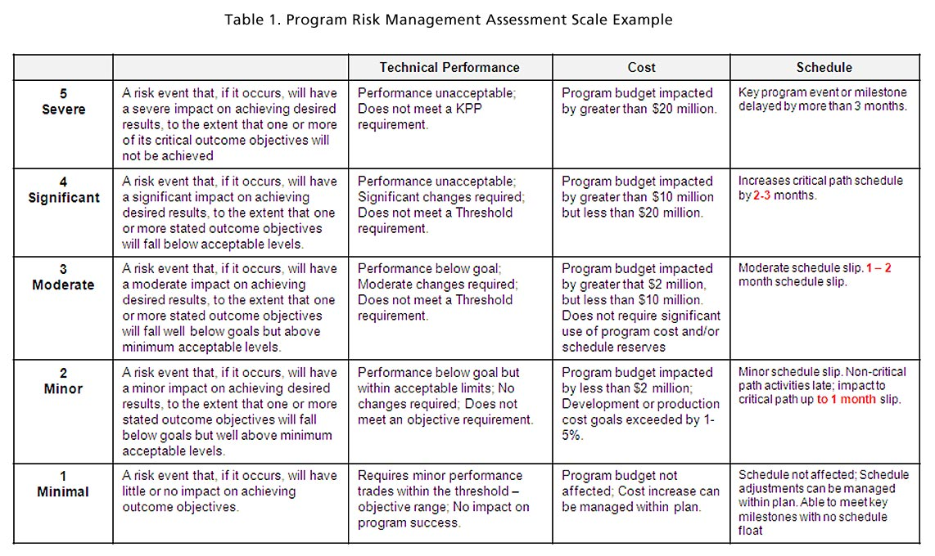

Figure 2 Risk Management Graph, (Mitre, 2018)

## Risk Types

There are four risk types my risk management is based off.

|  |  |
| --- | --- |
| **Risk Type** | **Description** |
| Reputational: | Loss of client confidence for completion of the project |
| Procedural: | Failure to follow project requirements |
| Project: | Running behind schedule, not completing key milestones, experiencing significant issues with the product. Last minute changes. |
| Human: | Illness or loss of key individual |

## Importance of Risk Management

Introduction mentioning why risk management is important, specifically to my circumstances.

• Small business – Club

• One-person project

More will be added to this section.

## Risk Management Plan

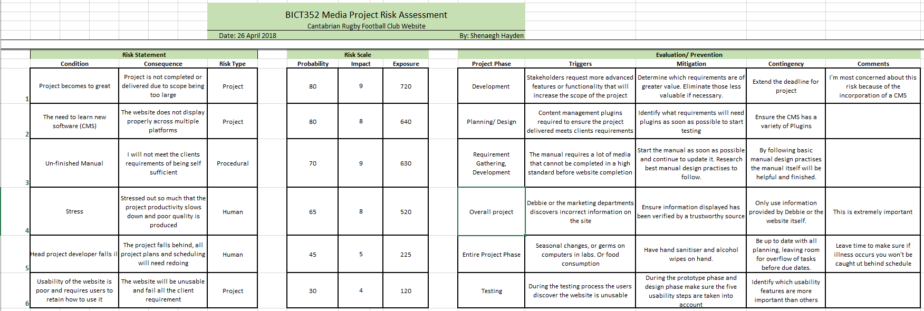Below is an example of my risk management plan that was revaluated weekly.

## Outcomes of Risk Management

* Examples of a mitigation plan in action

More will be added to this section

The entire weekly risk management plans will be in appendices in final report.

# Quality Assurance

Introduction regarding the importance of quality assurance, related to aspects of my project.

More will be added to this section

## Quality Assurance Plan

Below is an example of the first section of my quality assurance plan. This plan also involves my testing plan.

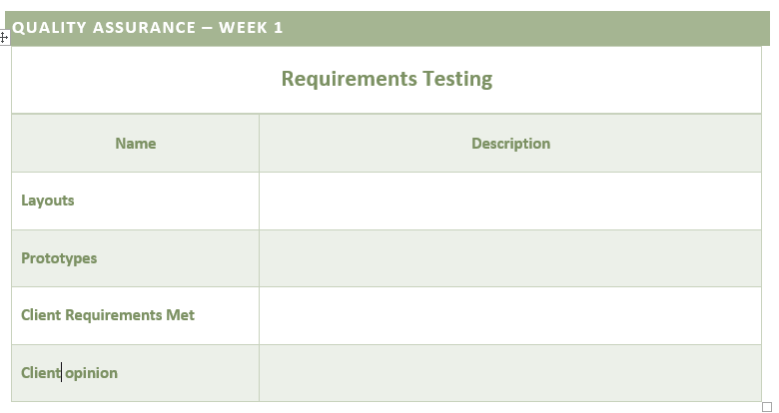

## Test Plan

More will be added to this section

### Features Tested

More will be added to this section

### Test Approach and Measurement

More will be added to this section

## Usability Testing

More will be added to this section

### Usability Metrics

Below are the identified usability metrics.

## Summary of Metrics

|  |  |  |  |  |
| --- | --- | --- | --- | --- |
| **Completion Rate** | **Task Time** | **Task Level Satisfaction** | **Test Level Satisfaction** | **Errors** |
| The rate of task completion. Will be recorded in a binary metric:  1 = Task success  0 = Task Failure | Task duration recorded in minutes or seconds. Task recording will begin when user read scenario and ends when scenario completed. | After each task attempt the participant will answer a difficulty question for said task. | At the end of the usability test, the participants are asked to answer three questions on their impression of the website. | Any unintended errors, or actions the user makes will be recorded with a description of the error. These will then be weighted on severity – critical or non-critical errors. |

### Overview of Metric

More will be added to this section

### Critical Errors

Below is the list of critical errors.

* An error that deviates the participant from completing a task
* Website returns wrong data values to participant
* The system does not return a correct output from participant

### Non-Critical Errors

Below is a list of non-critical errors. These types of errors a recoverable during a task and do not hinder task completion.

* Participant exceeds expected task time by >15
* Participant needs to ask for help during a task
* Participant is lead astray by GUI but eventually completes the task

### Subjective Evaluations

This is where Task/Test level satisfaction comes into play for each task and category. The system usability scale will give me a greater understanding of how the participants feels about the overall usability of the website.

### Usability Test Plan

|  |  |  |  |  |  |  |  |
| --- | --- | --- | --- | --- | --- | --- | --- |
| **First name:**  **Age:**  **Gender:**  **IT experience:** *e.g. basic, moderate, expert.* | | | **Strongly Disagree** | **Disagree** | **Neutral or Undecided** | **Agree** | **Strongly Agree** |
| **Navigation** | | | | | | | |
| N1 | Navigating the site is easy | |  |  |  |  |  |
| N2 | Navigating the site is easy | |  |  |  |  |  |
| N3 | Can access homepage on every page | |  |  |  |  |  |
| N4 | Users can always identify where they are in the site | |  |  |  |  |  |
| N5 | Hyperlinks display correct page when clicked | |  |  |  |  |  |
| N6 | Navigation menu is easy to follow | |  |  |  |  |  |
| N7 | Links open to correct information | |  |  |  |  |  |
| **Information** | | | | | | | |
| I1 | | The information on the website is relevant |  |  |  |  |  |
| I2 | | Find the information about members. That was an easy task? |  |  |  |  |  |
| I3 | | Find the information about game schedules. That was an easy task? |  |  |  |  |  |
| I4 | | It’s easy to find information |  |  |  |  |  |
| I5 | | Text is easy to read |  |  |  |  |  |
| I6 | | Easy to find contact details |  |  |  |  |  |
| I7 | | The information on the website is relevant |  |  |  |  |  |
| **Visual appearance** | | | | | | | |
| V1 | All images display the Cantabrian RFC adequately | |  |  |  |  |  |
| V2 | Images are high quality | |  |  |  |  |  |
| V3 | All images have a description | |  |  |  |  |  |
| V5 | The layout of the website is easy to navigate | |  |  |  |  |  |
| V6 | The colour scheme is consistent and appropriate | |  |  |  |  |  |
| V7 | There is a good visual balance on each page | |  |  |  |  |  |
| V8 | Fonts are appropriately used | |  |  |  |  |  |
| V9 | Buttons have effect when mouse is hovering over | |  |  |  |  |  |
| **Form** | | | | | | | |
| F1 | The form is easy to complete | |  |  |  |  |  |
| F2 | The fields are easy to follow | |  |  |  |  |  |
| F3 | The form fields did not erase when required fields were not filled out before submission? | |  |  |  |  |  |
| F4 | The form is easy to complete | |  |  |  |  |  |
| **Content** | | | | | | | |
| C1 | The sites purpose is clear | |  |  |  |  |  |
| C2 | Each page is identified | |  |  |  |  |  |
| C3 | All content is appropriate | |  |  |  |  |  |
| C4 | Users can copy content to the clipboard | |  |  |  |  |  |
| C5 | Every page has a heading | |  |  |  |  |  |
| **Technical** | | | | | | | |
| T1 | The website loaded quickly | |  |  |  |  |  |
| T2 | The site is usable with images disabled | |  |  |  |  |  |
| T3 | Th site has a help and support section | |  |  |  |  |  |
| T4 | The page layout works well in your browser – please note browser used | |  |  |  |  |  |
| T5 | The site adapts to orientation | |  |  |  |  |  |
| T6 | The website loaded quickly | |  |  |  |  |  |
| T7 | The site is usable with images disabled | |  |  |  |  |  |
| T8 | Th site has a help and support section | |  |  |  |  |  |
| T9 | The page layout works well in your browser – please note browser used | |  |  |  |  |  |
| T10 | The site adapts to orientation | |  |  |  |  |  |
| T11 | Mobile Site meets Desktop standard | |  |  |  |  |  |
| T12 | Mobile layout is easy to navigate | |  |  |  |  |  |
| **Feedback or Recommendations:** | | | | | | | |

## Functionality Testing

More will be added to this section

Similar to above section example.

## Outcomes of QA Plan

* Example of a QA task being carried out, and how it affected the project
* Mention the testing process, which is part of quality assurance
* Mention the metrics. Show how well the project succeeded. Provide a brief description about why the project did well / not so well in that area.
* Mention that the detailed quality assurance documents are placed in the appendices

# Content Audit

More will be added to this section

# Website Architecture Plan

More will be added to this section

# Methodoligies Essay

More will be added to this section

# Content Management System

More will be added to this section

# Website Design

More will be added to this section

## Wireframe

More will be added to this section

# Training Manual

More will be added to this section

## Concept

More will be added to this section

## Outcomes

More will be added to this section

# Reflection

# Appendices

# References

Mesiter Task. (2018). *Meister Task*. Retrieved from Meister Task: https://www.meistertask.com/

Mitre. (2018). *Risk Impact Assessment and Prioritization*. Retrieved from Systems Engineering Guide: https://www.mitre.org/publications/systems-engineering-guide/acquisition-systems-engineering/risk-management/risk-impact-assessment-and-prioritizationMiter